

AI Assisted Problem Solving Using Python

AcademicYear:2025-2026

Assignment Type: Lab
Assig_No. 2

Submitted by:
Name: NUKALA MEGHANA SRI
Enroll No. 2503b05113
Course: M-Tech CSE

Submitted to:
Name: Venkataramana Veeramsetty
Title: Course Instructor

Date: 28 Oct 2025

Q 1: Expected Output#1
Functional code with output and screenshot

Functional code:
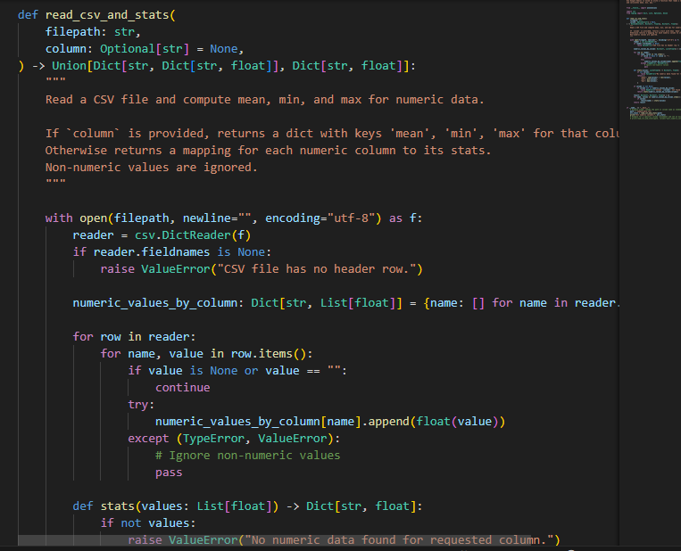

Output screenshot:
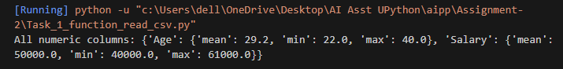

Q 2: Expected Output#2
Side-by-side comparison and observations

Copilot
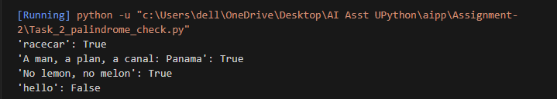

Gemini
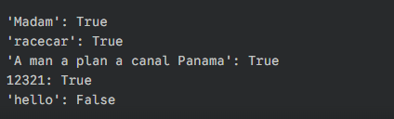

Q3: Expected Output #3
Detailed explanation
Line(s) | Code Snippet | Explanation
1 | import math | Imports the built-in math module, which provides access to mathematical functions and constants, most notably math.pi (the value of pi), needed for circle calculations.
3 | def calculate_area(name): | Defines a function named calculate_area that accepts one parameter: name (a string representing the shape's name).
7 | name = name.lower() | Converts the input name string to lowercase to ensure the function is case-insensitive (e.g., "Rectangle" or "rectangle" both work).
9 | if name == "rectangle": | Starts a conditional block. Checks if the lowercase shape name is "rectangle".
10 | l = float(input(...)) | If it's a rectangle, prompts the user for the length and converts the input to a floating-point number (allowing for decimal values).
11 | w = float(input(...)) | Prompts the user for the width, also converting the input to a float.
12 | rect_area = l * w | Calculates the area of the rectangle (Area = Length $\times$ Width).
13 | print(f"...") | Prints the calculated area using an f-string for formatted output.
15 | elif name == "circle": | Checks the next condition. If the first if failed, it checks if the shape name is "circle".
16 | r = float(input(...)) | If it's a circle, prompts the user for the radius and converts the input to a float.
17 | circ_area = math.pi * r**2 | Calculates the area of the circle (Area = $\pi \times r^2$), using math.pi and the exponent operator **2.
18 | print(f"...") | Prints the calculated circle area.
20 | elif name == "triangle": | Checks the next condition. If the previous checks failed, it checks if the shape name is "triangle".
21 | b = float(input(...)) | If it's a triangle, prompts the user for the base length and converts it to a float.
22 | h = float(input(...)) | Prompts the user for the height, converting it to a float.
23 | tri_area = 0.5 * b * h | Calculates the area of the triangle (Area = $\frac{1}{2} \times \text{Base} \times \text{Height}$).
24 | print(f"...") | Prints the calculated triangle area.
26 | else: | The final block—runs if none of the preceding conditions (if or elif) were true.
27 | print("...") | Prints an error message indicating the shape is not supported by the function.

code snippet
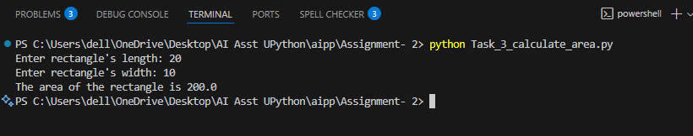

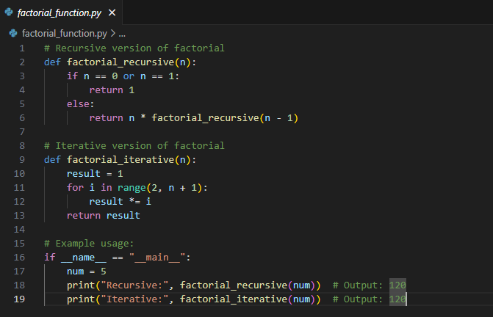

Output: Two working factorial implementations
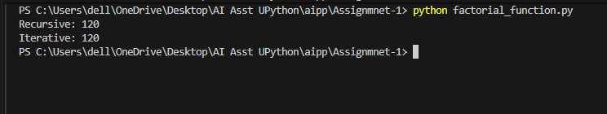

Q 5: Use Copilot to find the largest number in a list. Assess code quality and efficiency
Code:
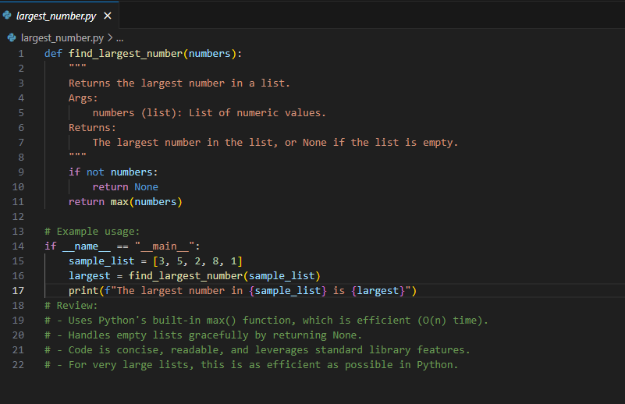

Output: A valid function with your review
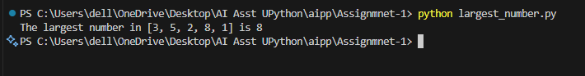

Q: Expected Output #4
Screenshots of working environments with few prompts to generate python code

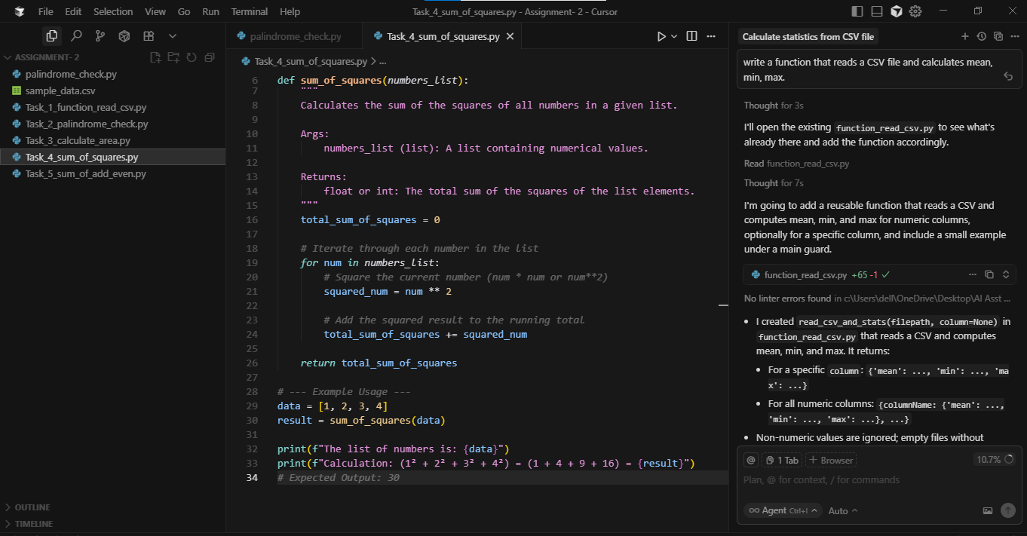

Q 5: Expected Output#5
Refactored code written by student with improved logic

def calculate_odd_even_sum(numbers_list):
odd_sum = 0
even_sum = 0

for num in numbers_list:
if num % 2 == 0:
even_sum += num
else:
odd_sum += num

return odd_sum, even_sum

list_num = [2, 3, 4, 5, 6, 7, 8, 9]

odd_sum, even_sum = calculate_odd_even_sum(list_num)

print(f"List: {list_num}")
print(f"The sum of odd numbers is {odd_sum}")
print(f"The sum of even numbers is {even_sum}")

